RIHAM AHAMED ABDUL RAHEEM

HND COMPUTING IDM

Final report

Contents

**EMERGING BANKING TECHNOLOGY IN THE MODERN WORLD** **Error! Bookmark not defined.**

As for Sri Lanka: **Error! Bookmark not defined.**

References **Error! Bookmark not defined.**

**List of figure**

Figure 1: Banking technology **Error! Bookmark not defined.**

# **PROJECT ANALYSIS**

Figure 1: Gun chart

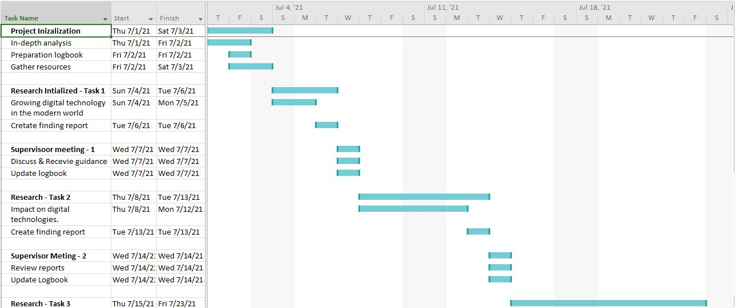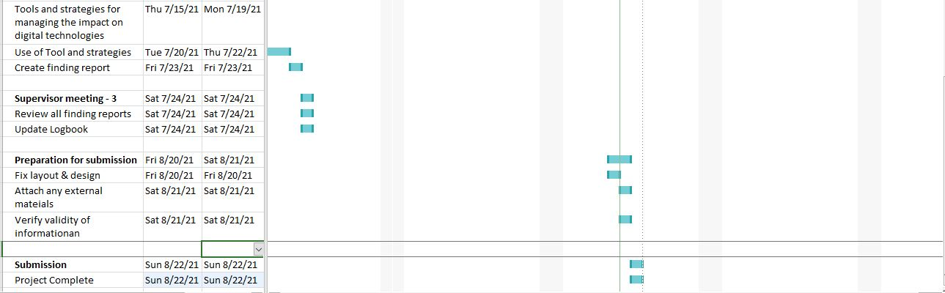

## Scope

The primary scope of this project is to properly identify what vulnerabilities are created during development and how to effectively counter said problems. As such small scale research will be done both qualitatively and quantitatively in order to satisfy the scope of this project.

The Gantt chart above illustrates the path the project will follow at a glance.

## Objective

During this project all the information that has been obtained through research will be documented below as findings. Findings will contain not only about problems but also solutions and recommendations to avoid said problems.

Upon the completion of the project, we hope to bring awareness to the developer teams in such a way that the new banking project will follow suit with as less vulnerabilities in the system as possible.

## Work breakdown

Initially as project manager, I analyzed the project thoroughly and extracted what information I can use to equip myself with in order to narrow down the margins during research. Then I gathered or created the necessary resources I required, such as the software. An empty logbook template was designed by my hand as the one I was provided with was a hassle to maintain.

Afterwards, I did a simple research to Modern digital banging, and then decided on doing quantitative and qualitative research depending on the background of the specific topic.

## Project Principals

All these steps have been taken in order to critically organize my workflow. Project management tips and standards have been followed; this document will bear witness to their usage.

I have employed quantitative and qualitative research methodologies that will satisfy the scope of the project.

**Qualitative research interviews**

I performed one to one interview with my supervisor in order to gather any information I could about the topics I’ve already picked. I ensured that I kept an open mind and never came close to a conclusion. I did this as it’s a great opportunity to get a deeper understanding of a user’s point of view regarding a product, service or company.

An interview allows you to ask follow-up questions to delve deeper, but this brings with it its own hazards too. A careless interviewer can potentially bias interviewee answers by asking leading questions that don’t subsequently provide a true reflection of a user’s opinion.

**Qualitative case studies**

Case studies provide projects with an even more comprehensive understanding of how an individual interacts with a product or service. It gives you a more complete picture of their satisfaction, usage and attitudes towards a specific product, service or industry in appropriate context.

**Quantitative research performed with existing forums**

This personally allowed me to identify the topics clearly, and why one should conduct research in order to produce a report with related to said topics.

* Attaché my finding report 1,2 and 3 in this file.